**Event e-Seat Number System**

1/06/2020-21/08/2020

**Project Supervisor:**

**Ms Tan Ai Lian**

**tan_ai_lian@nyp.edu.sg**

**6550 0616**

**Ms Lauren Tan**

**lauren_tan@nyp.edu.sg**

**6550 1677**

**Project Students:**

**Dylan Chan Kah Hoe 181586L**

**Randy Chong Jun Er 181773X**

## Content Page

**Content Page 2**

**Project Overview 3**

**Project Specifications 3**

**Project Implementation 3-4**

**Timeline 4**

**Empathy Map (Planning) 6**

**Empathy Map (Issuing) 6**

**Journey Map 7**

**Mindmap 8**

**50 Ideas 9**

**Decision Matrix 9**

**Use Case Diagram 10**

**System Diagram 11**

**Database Diagram 11**

**Site Map 12**

**Prototype 13-17**

**Installation Guide 18-19**

**User Guide 20-29**

**Reflection 30**

**Areas for Improvement 30**

**Project Challenges 31**

**Conclusion 31**

**Project Overview**

**To propose a solution to automate the ticketing and ushering process for mega-events conducted in NYP. The current system uses physical tickets that have to be printed and then manually cut and then given out to the parents when they arrive.**

**Currently, problems faced by the users include:**

* **Printing out thousands of tickets for the event and cutting them**
* **Mixing up tickets or printing double causing confusion**
* **Waste of paper as tickets only used once**

**The solution aims to reduce the printing of parent seat tickets on paper and improve work productivity by automating the seating planning process.**

**Project Specification**

**Students will use the design thinking process to design a solution that will help automate the process of the seating planning process and to also reduce the printing of seat tickets on paper which can improve work productivity.**

**It will comprise of an algorithm that can intelligently allocate seating arrangements and the rules of the allocation will be dynamic based on the live ticketing condition and constraints of the venue. The system will also be able to be self-learning and improve on its ticketing algorithm based on the feedback and experience given by its users.**

**The system will be able to send the seat e-ticket to an audience member via mobile.**

**The System will be implemented on Windows and mobile devices.**

**Project Implementation**

## **Device Used**

* Windows Pc (Windows 10 OS)

## **Software Used**

* Visual Studio Code
* ASP.NET

## **Programming Environment**

## Visual Studio 2015

**Timeline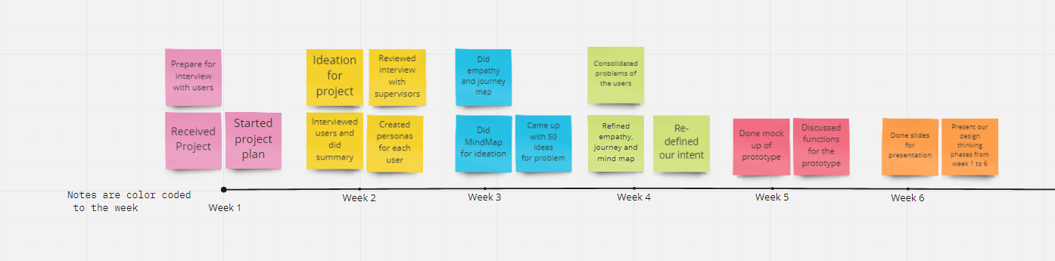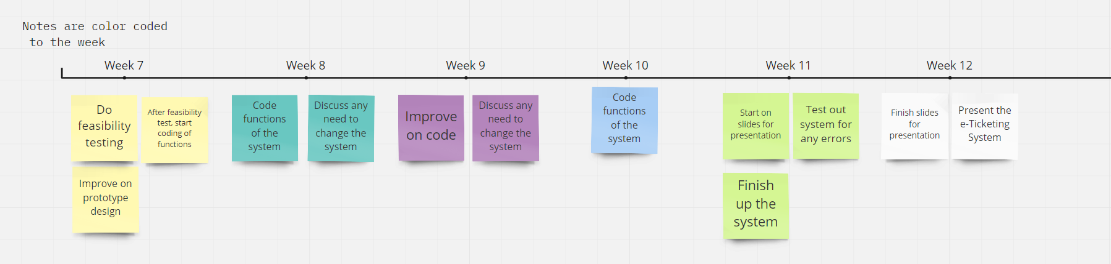Design Thinking Phases**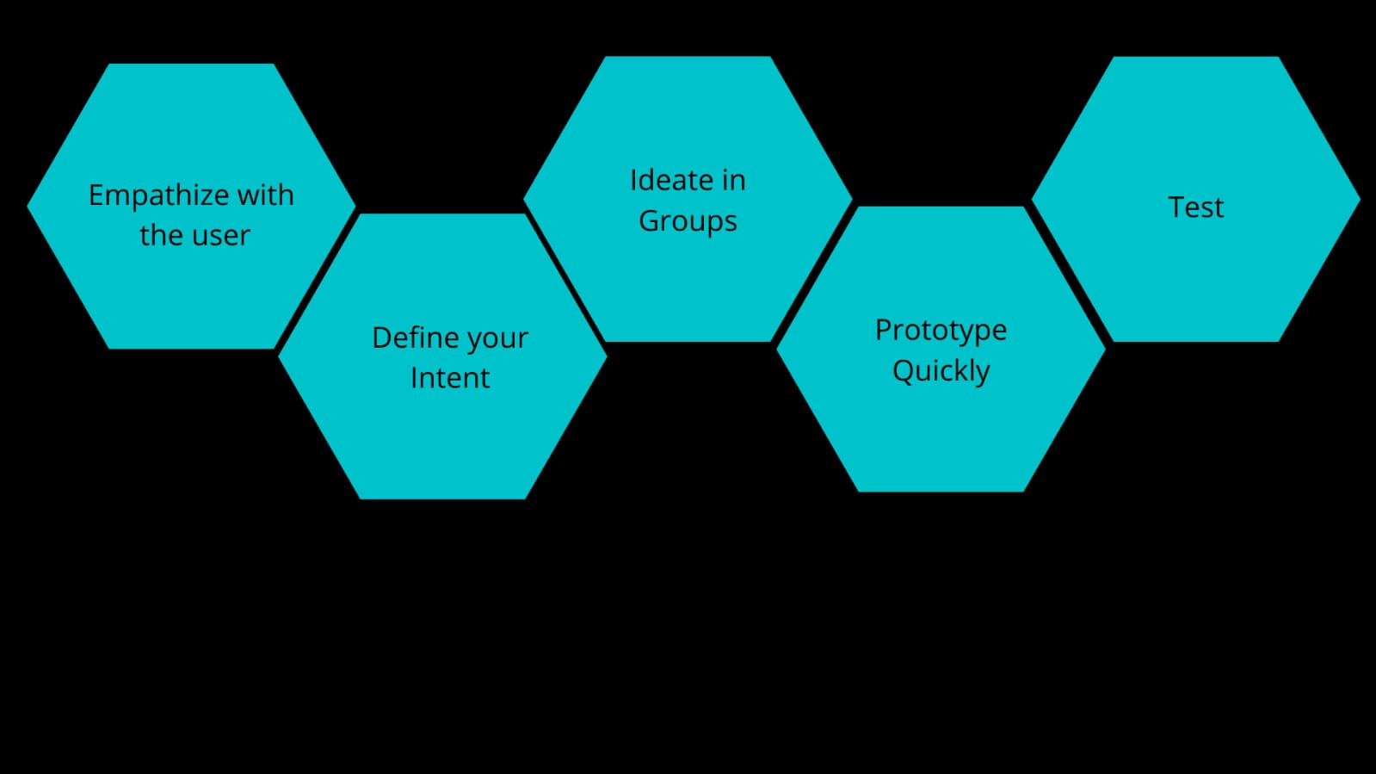

**During the FYP we applied the design thinking process to assist us in developing our project by guiding us to what we need to accomplish for the system and how we were going to do that**

**The first phase is to empathise with your users. We did this by first creating various empathy, journey and mind maps to help further our understanding**

**Empathize with the user**

**The empathize with the user phase allows us to understand the user of the system better to give us information on what our user would want and what we can do to assist them when carrying out their role. From this phase, we have come up with an empathy map or both issuing and planning and a journey map for both personas**

**Empathy map (Planning)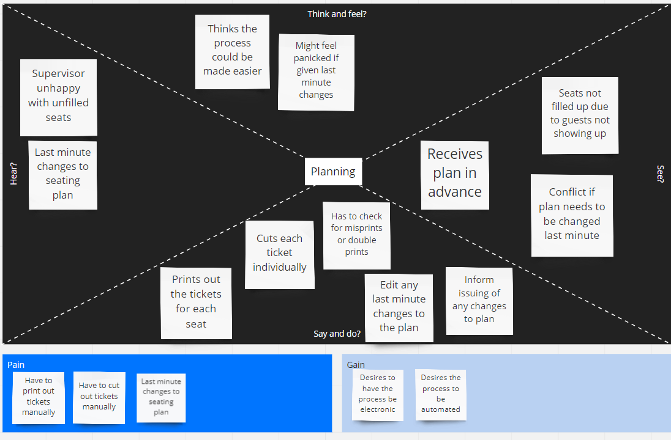Empathy map(Issuing)**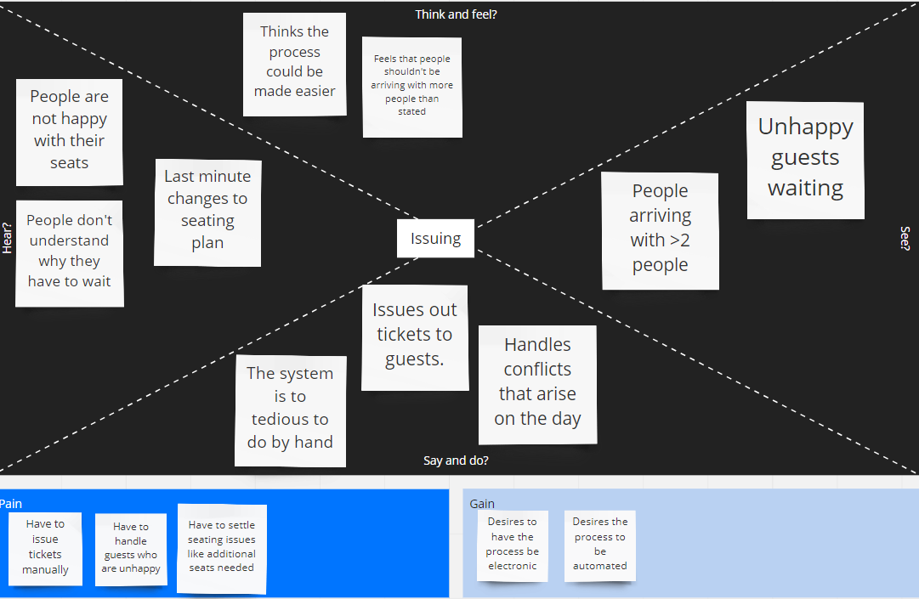

**Journey Map**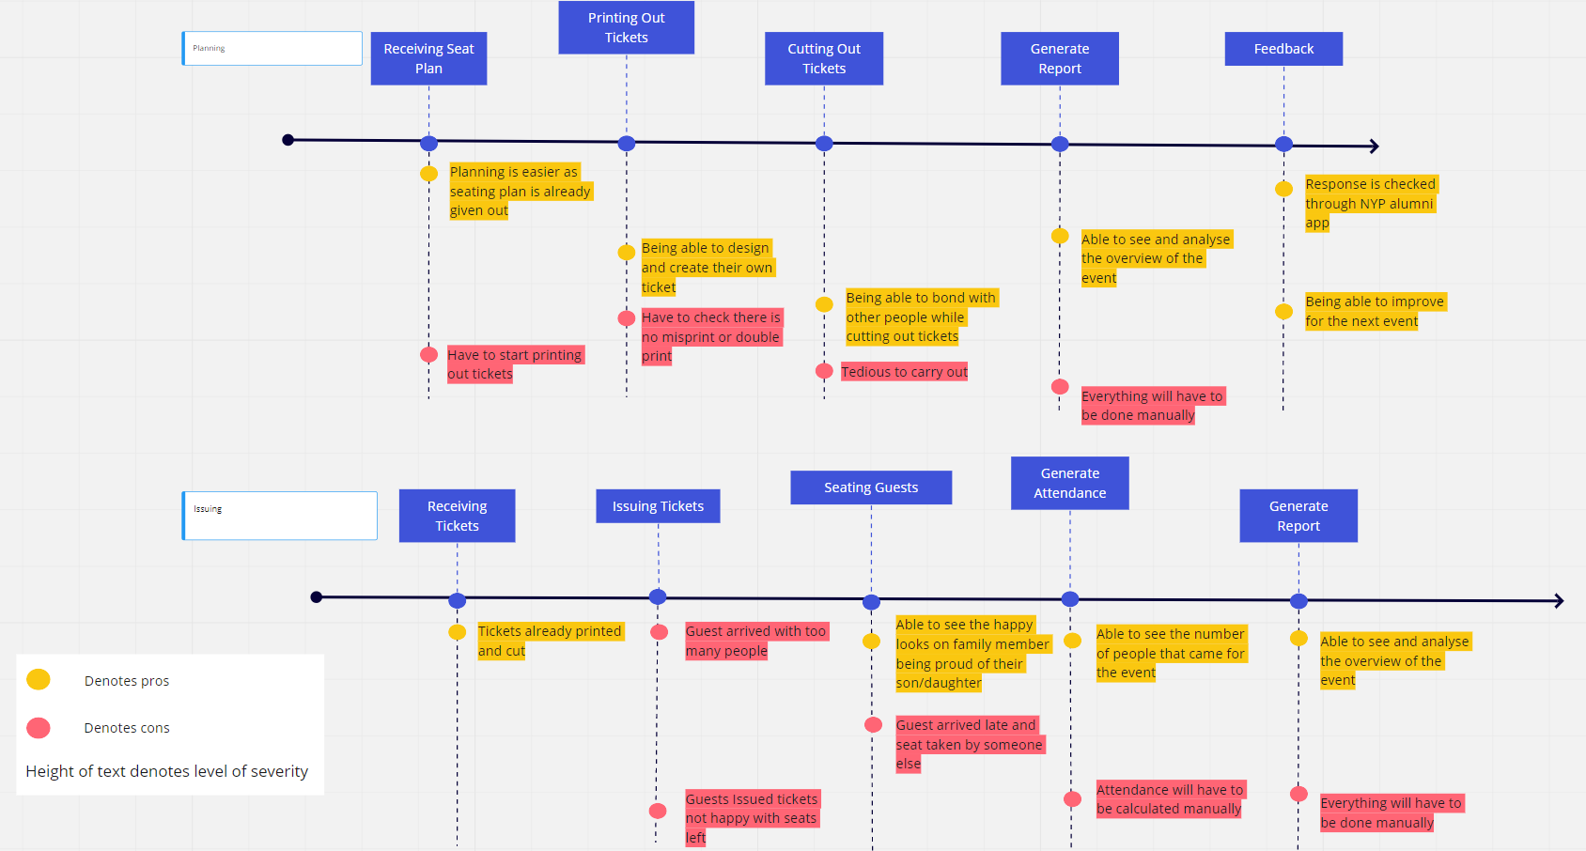

**Define your Intent**

**The define your intent phase is to gain more insight into the problems faced by the users and essentially think of what you can do to solve the problem**

**We came up with a mind map to further explore how certain solutions would affect the user experience and whether it would be efficient**

**Mindmap**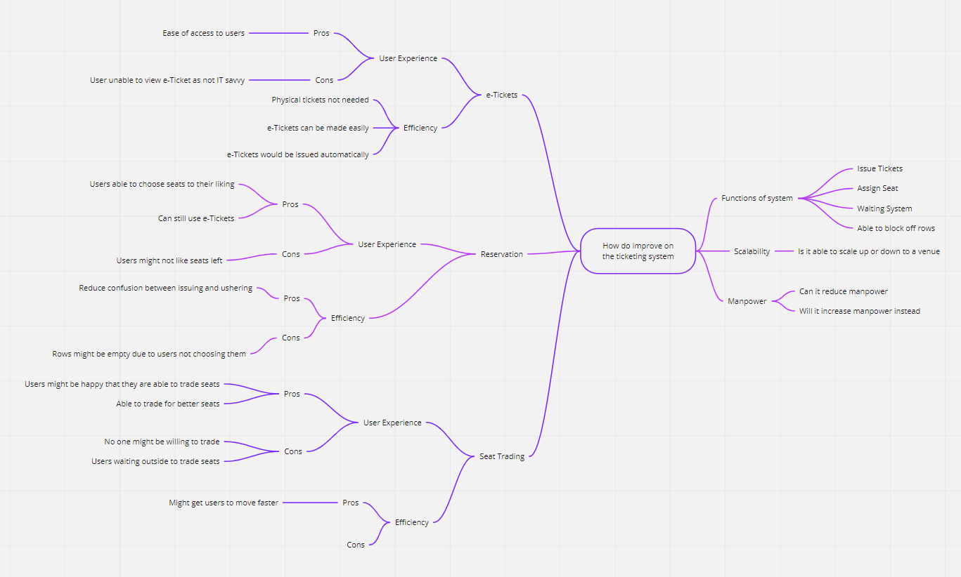

**Ideation**

**The ideation phase is to come up with ideas that can become the solution to the problem at hand or any additional features you may be able to implement into your solution**

**50 Ideas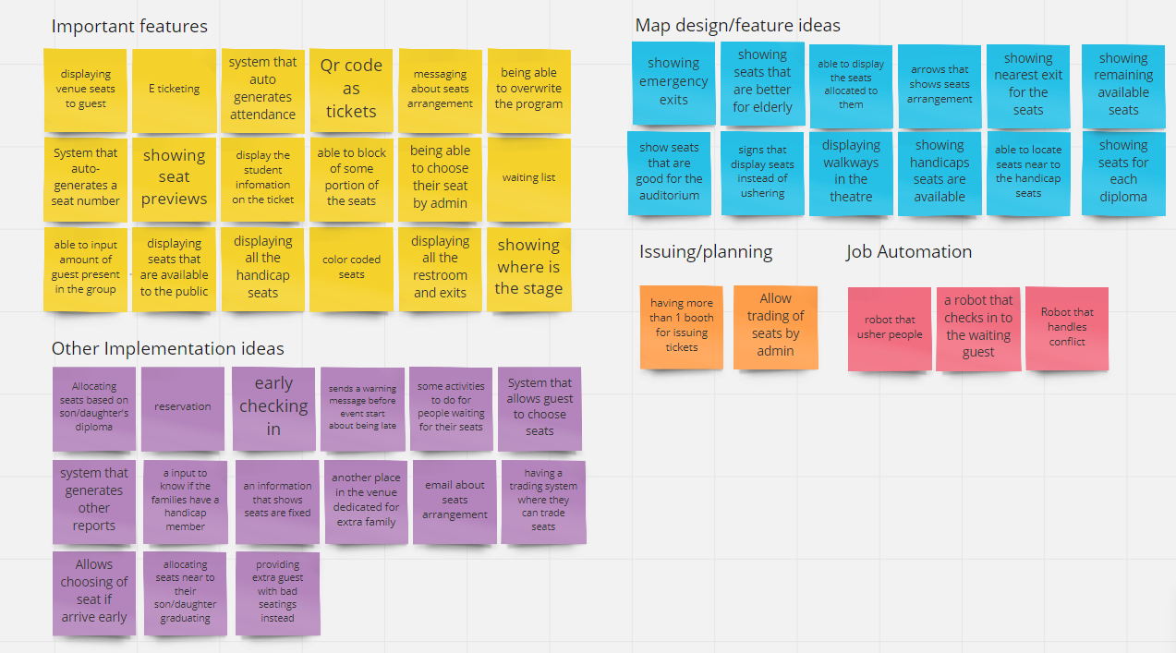Decision Matrix**

|  |  |  |  |  |
| --- | --- | --- | --- | --- |
| Idea selected (Score) | Desirability | Feasibility | Viability | Novelty |
| e-Ticketing (10) | 3 | 3 | 3 | 1 |
| Waiting List(7) | 2 | 2 | 2 | 1 |
| Generating Reports(9) | 3 | 3 | 2 | 1 |

**Use Case Diagram**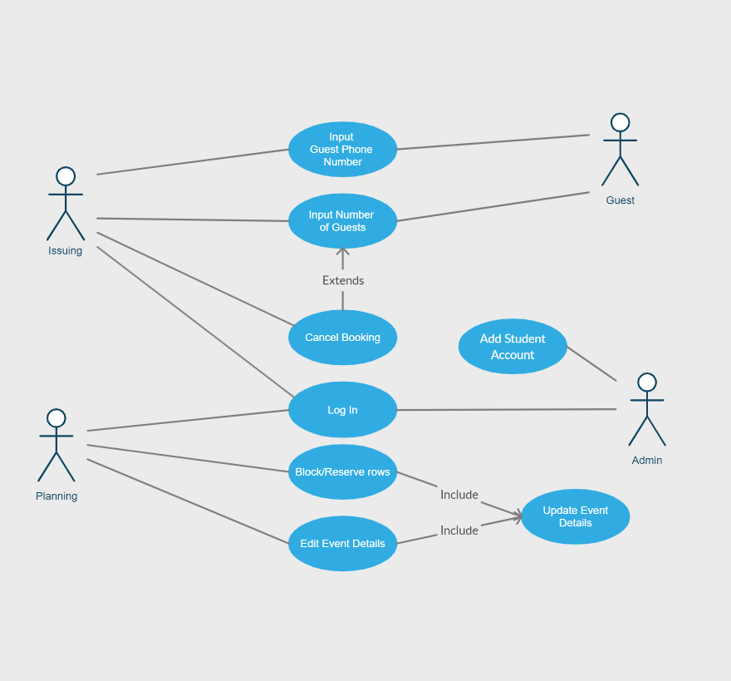

**Database Diagram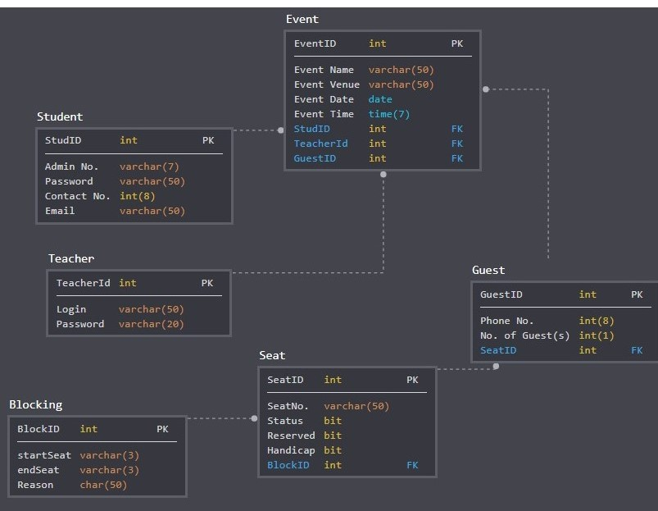System Diagram**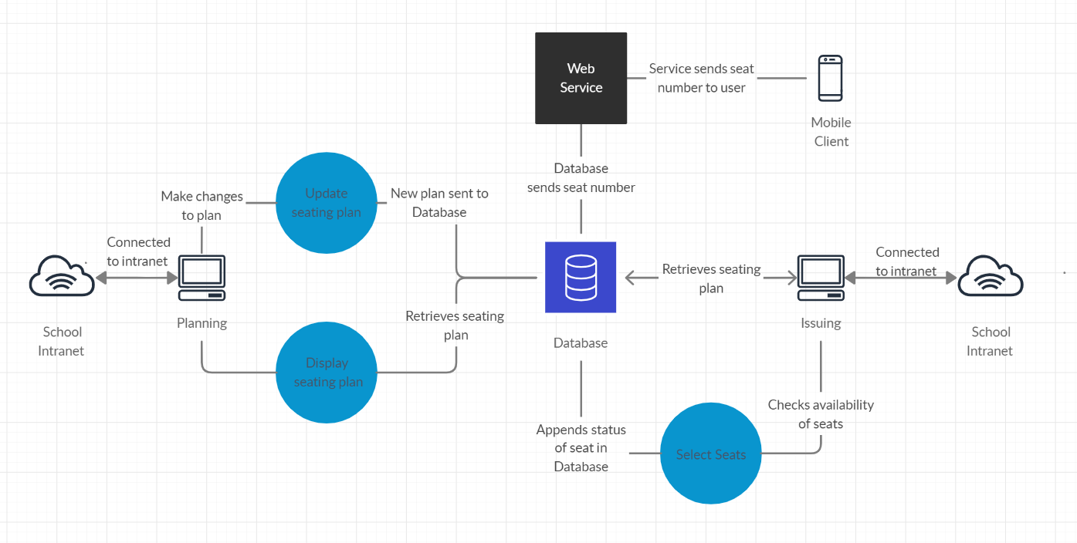

**Site Map**

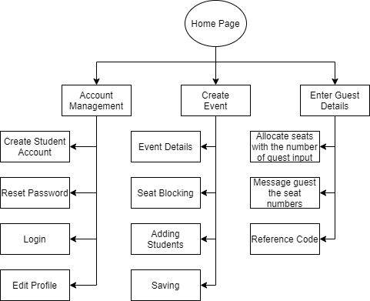

**Prototype Quickly**

## **Log In**

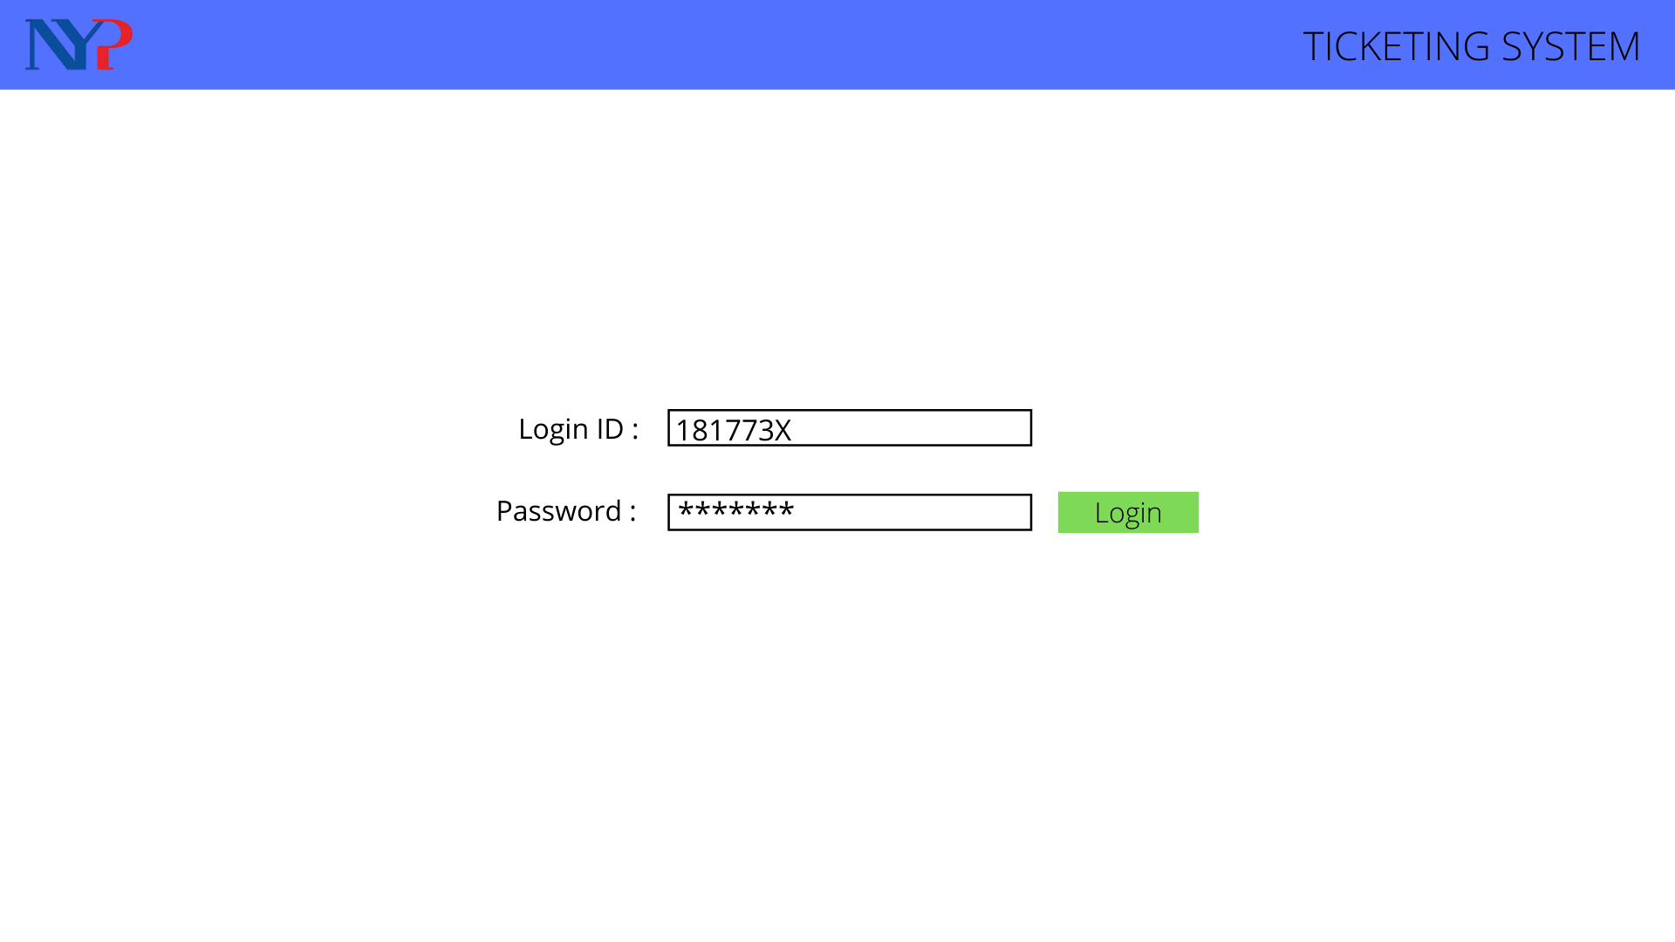

## **Student Dashboard**

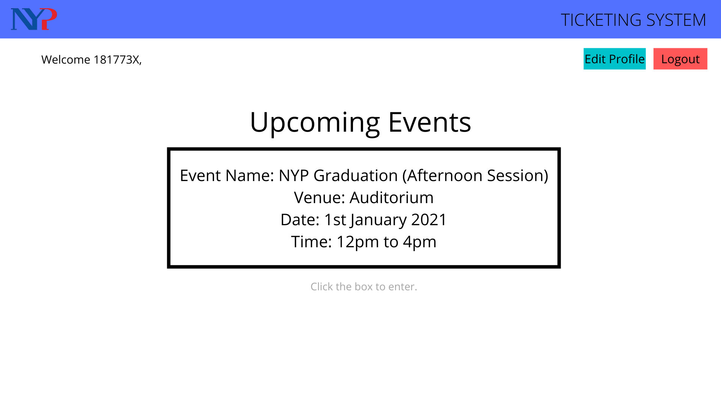

## **Guest input**

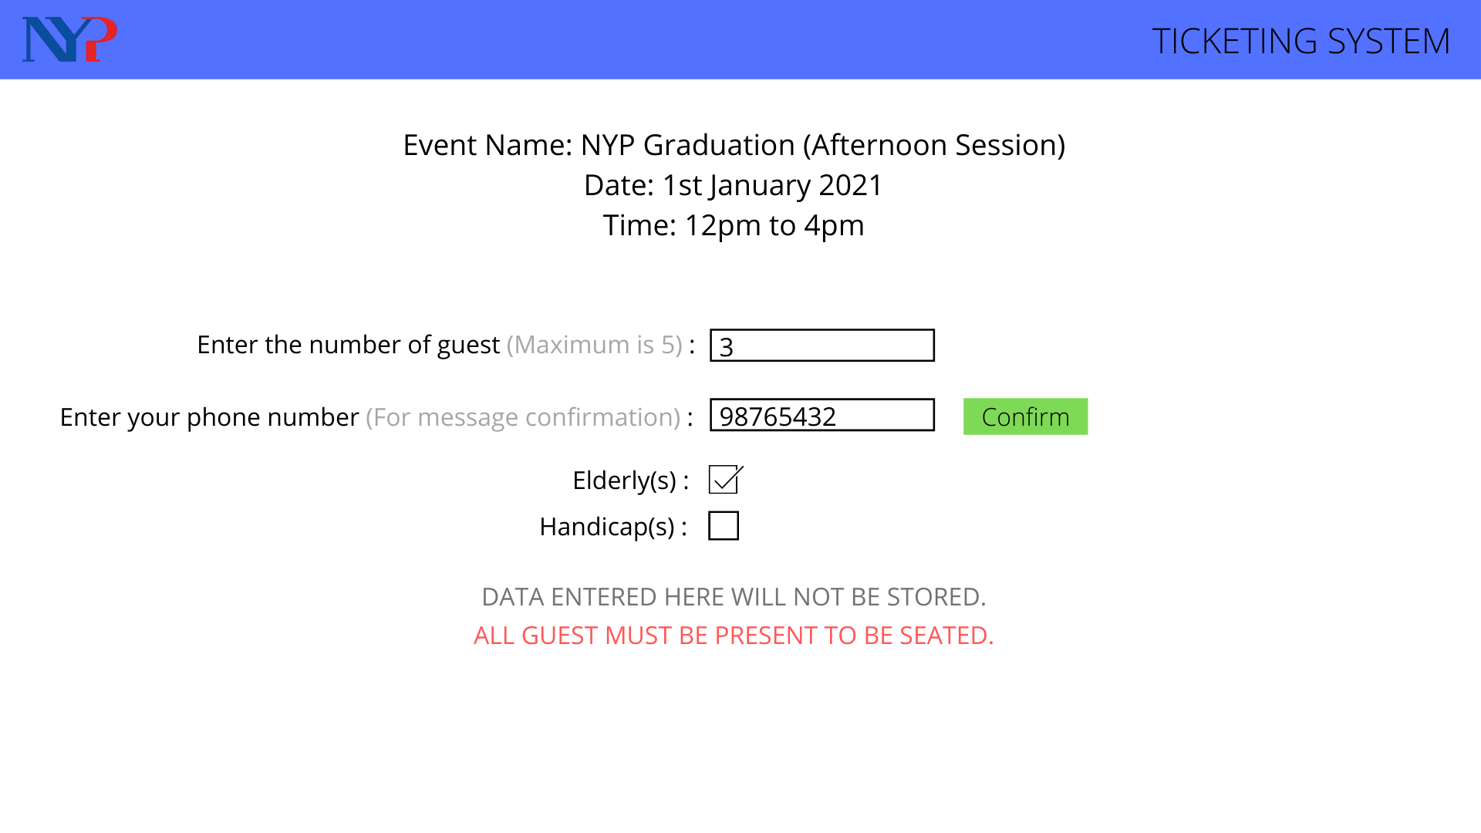

## **Confirmation page**

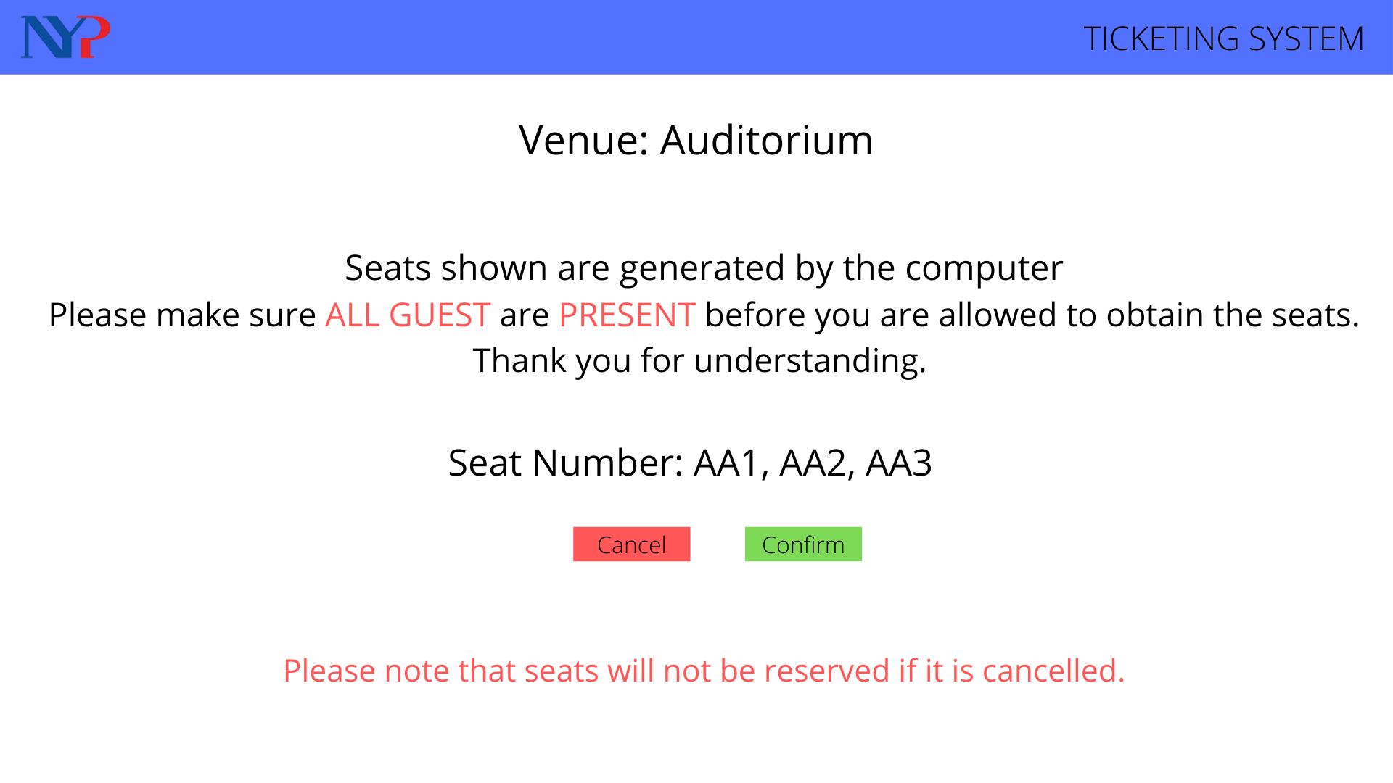

## **Reservation Cancelling**

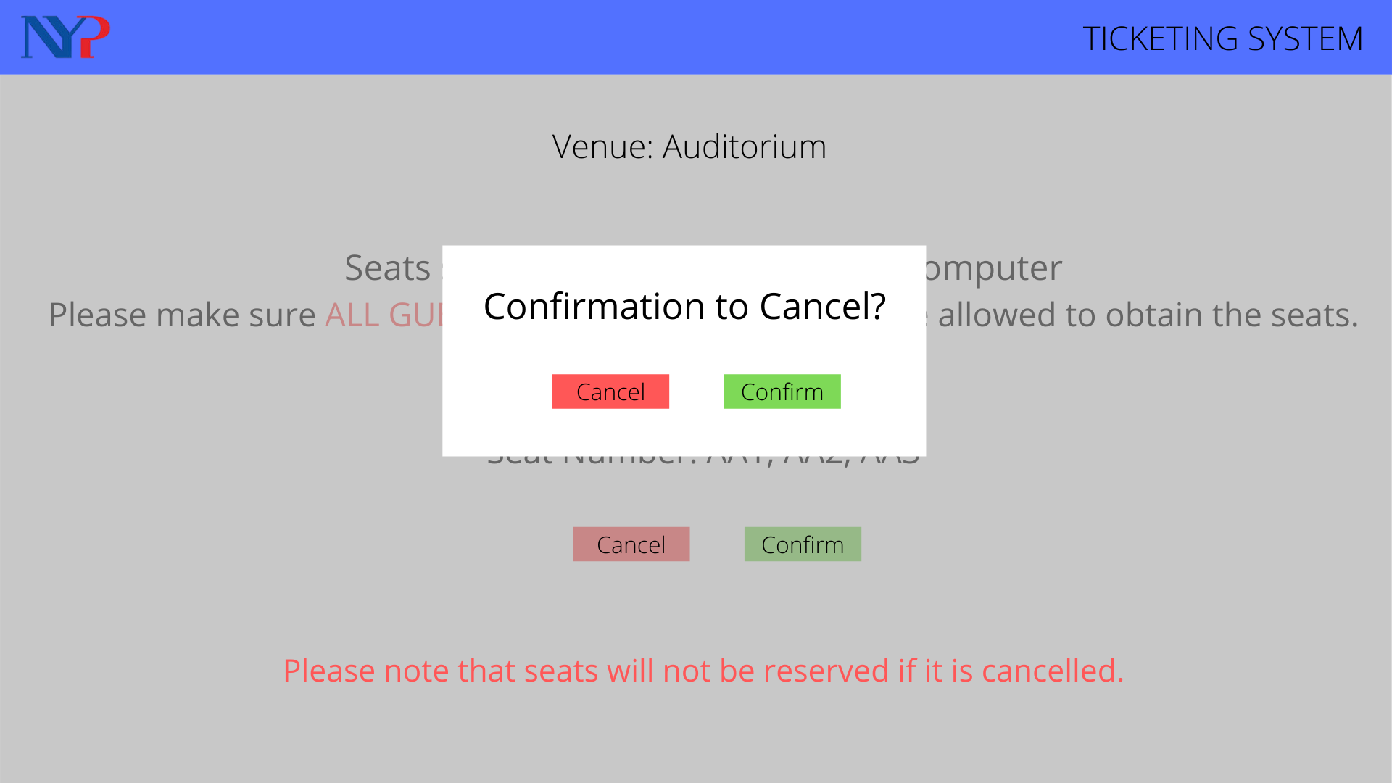

## **Planner Dashboard**

## **Event Details**

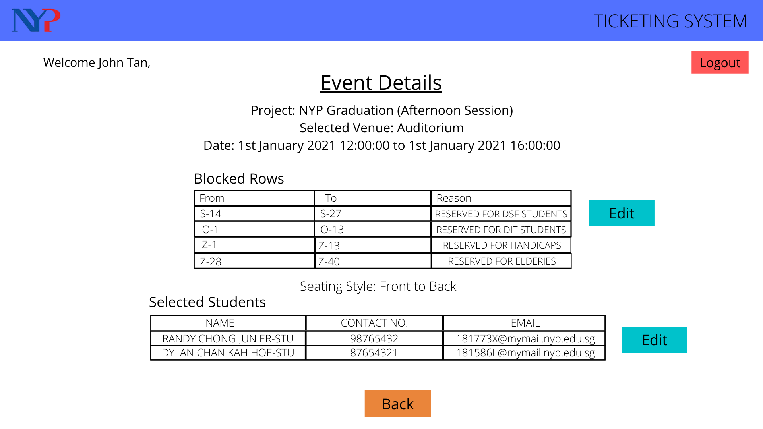

## **Seat Blocking/Reservation**

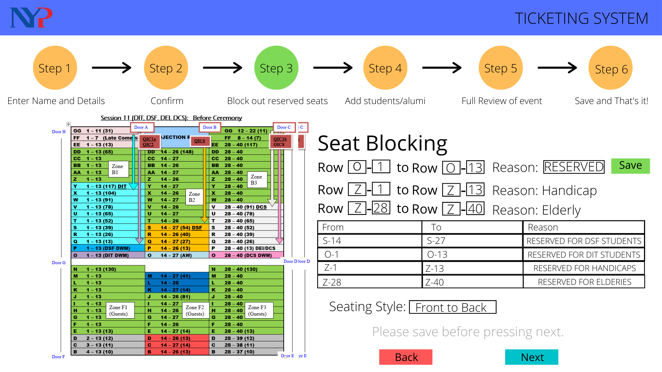

## **Review Event**

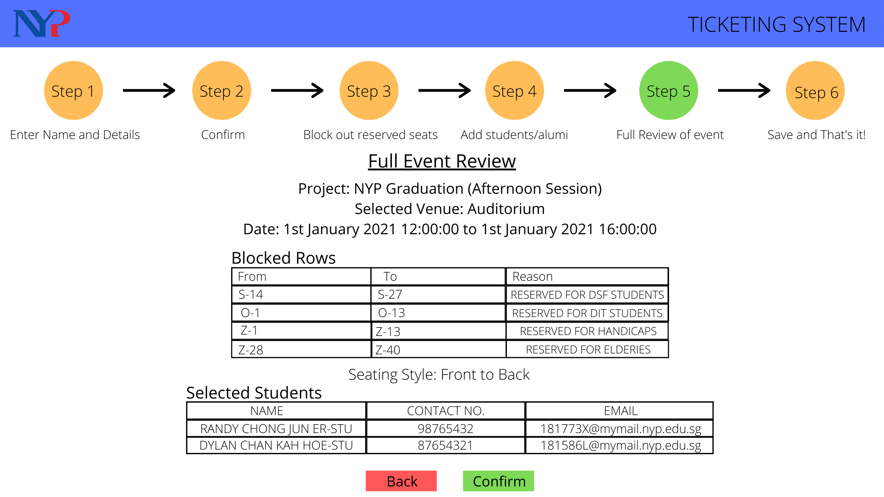

**Installation Guide**

Firstly, you have to download and install Visual Studio 2015 community version here:

<https://visualstudio.microsoft.com/vs/older-downloads/>

Secondly, open up Visual Studio and click on open new website under File > Open > Web Site

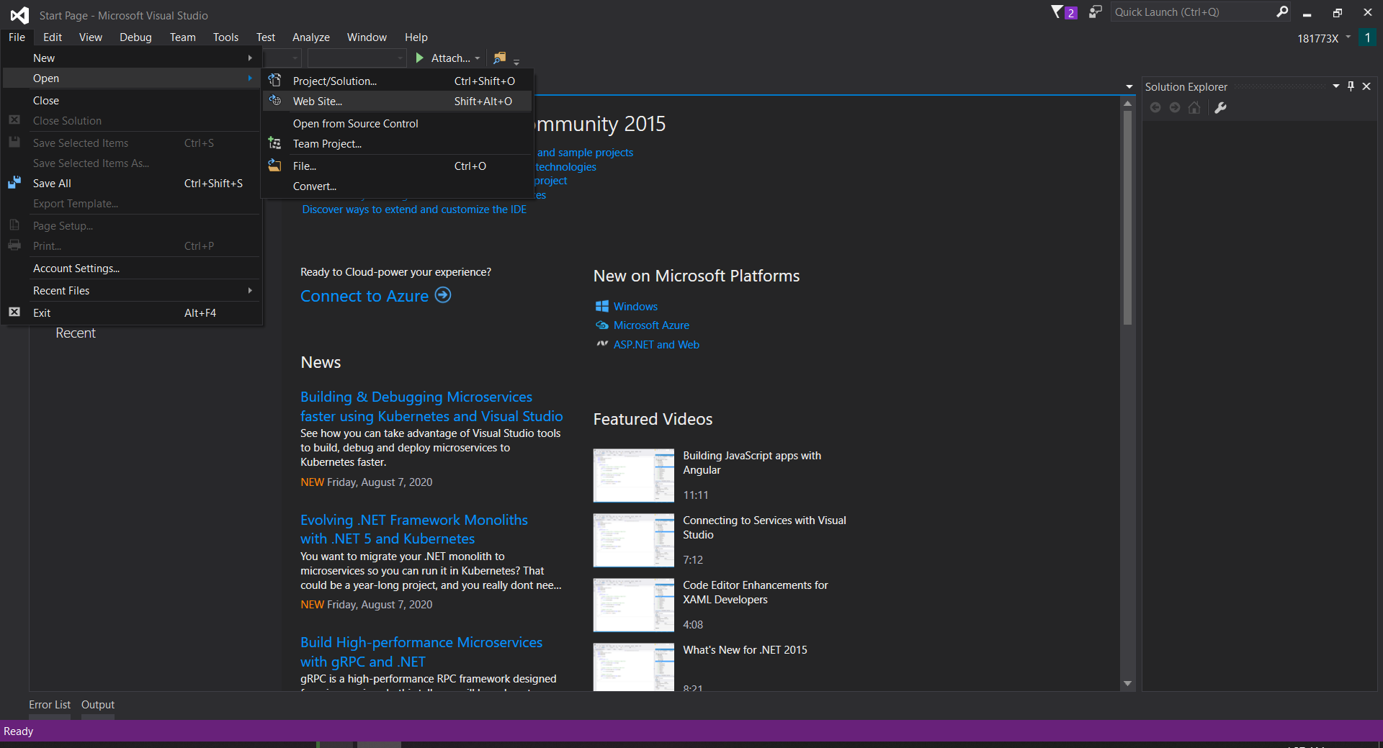

Select the folder E-ticketing

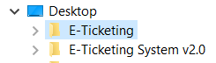

Once the folder is opened, clicked on the default browser on the top of the screen to run the website

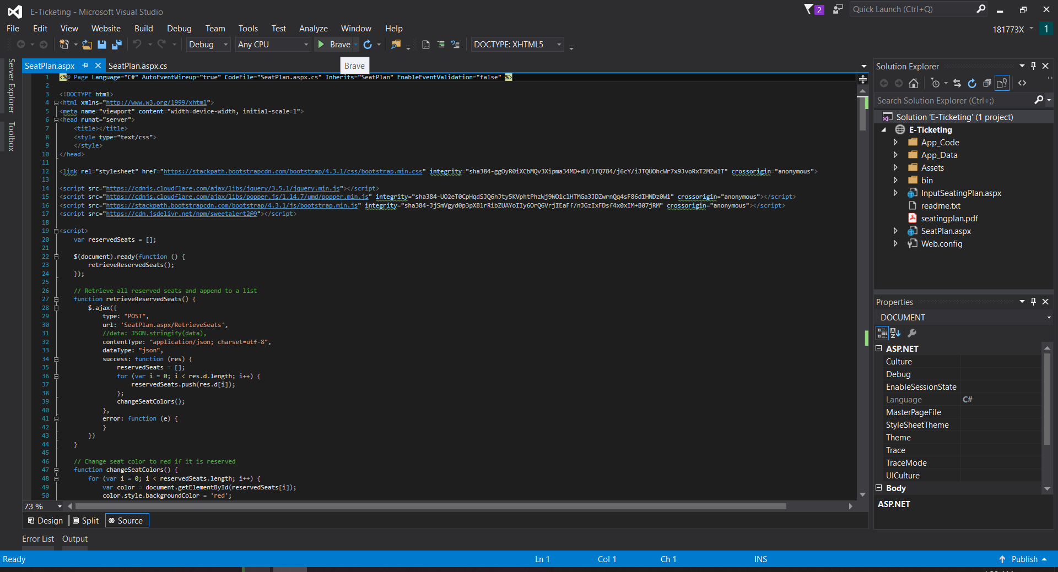

Once it is open, the installation is complete and the following website should appear

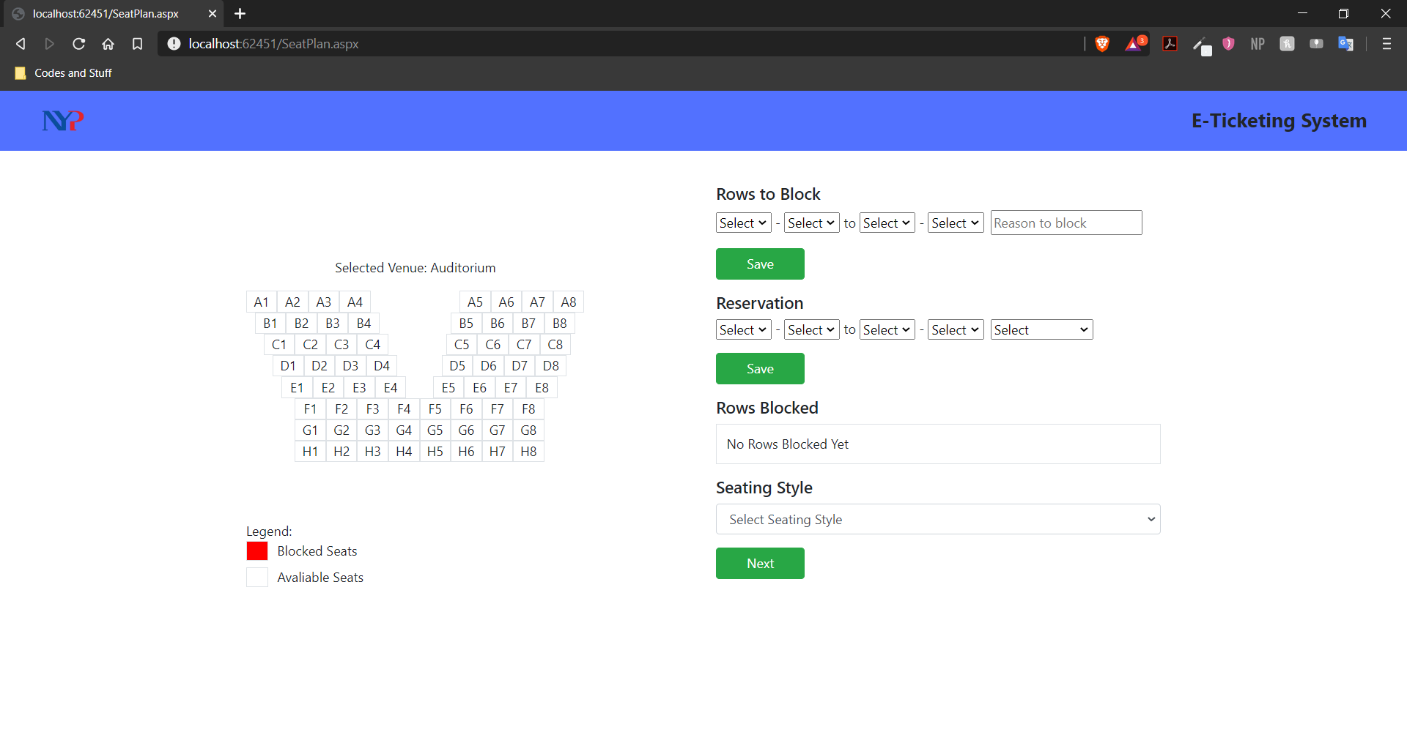

**User Guide**

Firstly once you have launched the website, it will look like this



To block a seat, firstly you would have to select a seat alphabet and a number as the starting seat from the first 2 dropdown list under the Rows to block.

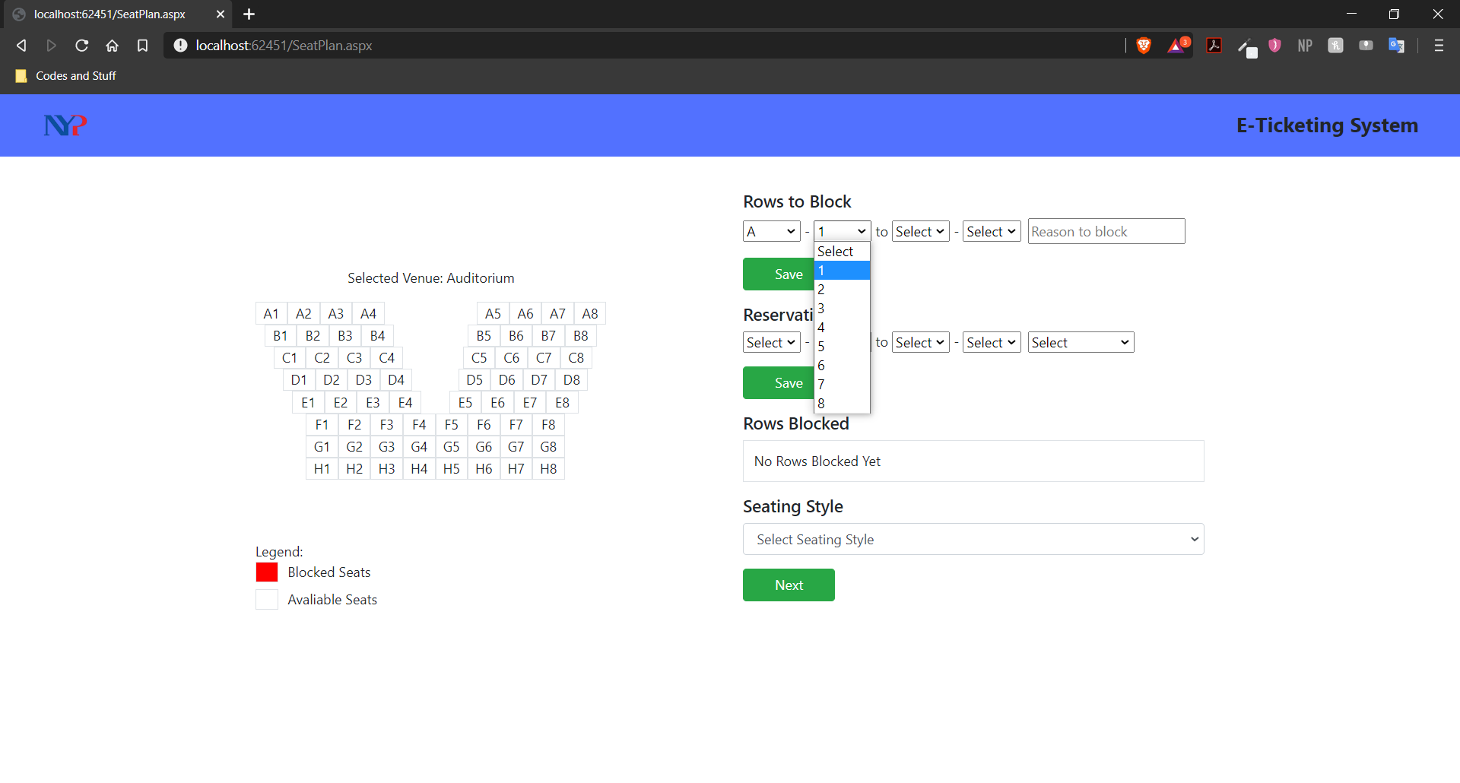

Afterwards, you would have to select the ending seat alphabet and number from the last 2 dropdown list under the same row.

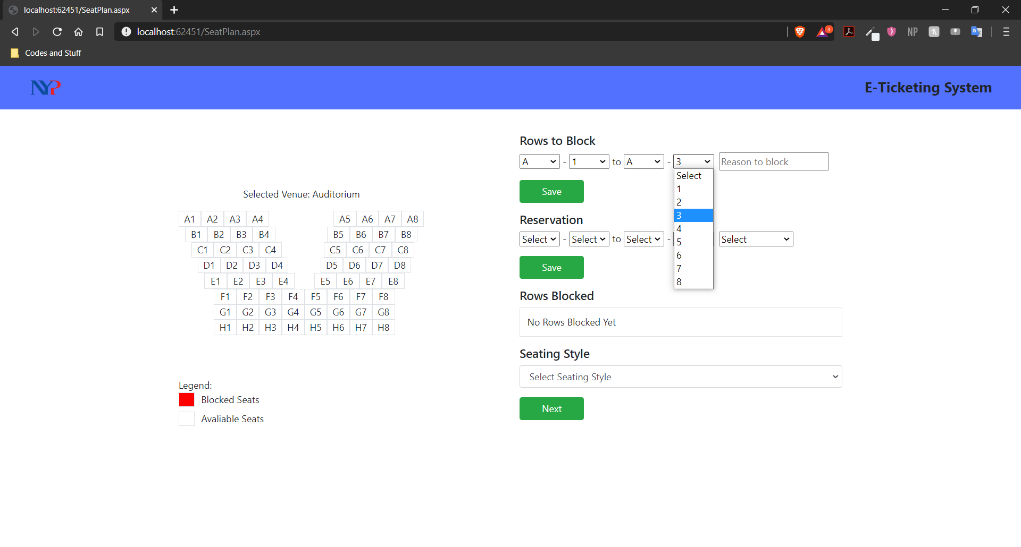

Input the reason as why you would want to block the selected rows. (If no reason is imputed, the default reason will be “No Reason Input”)

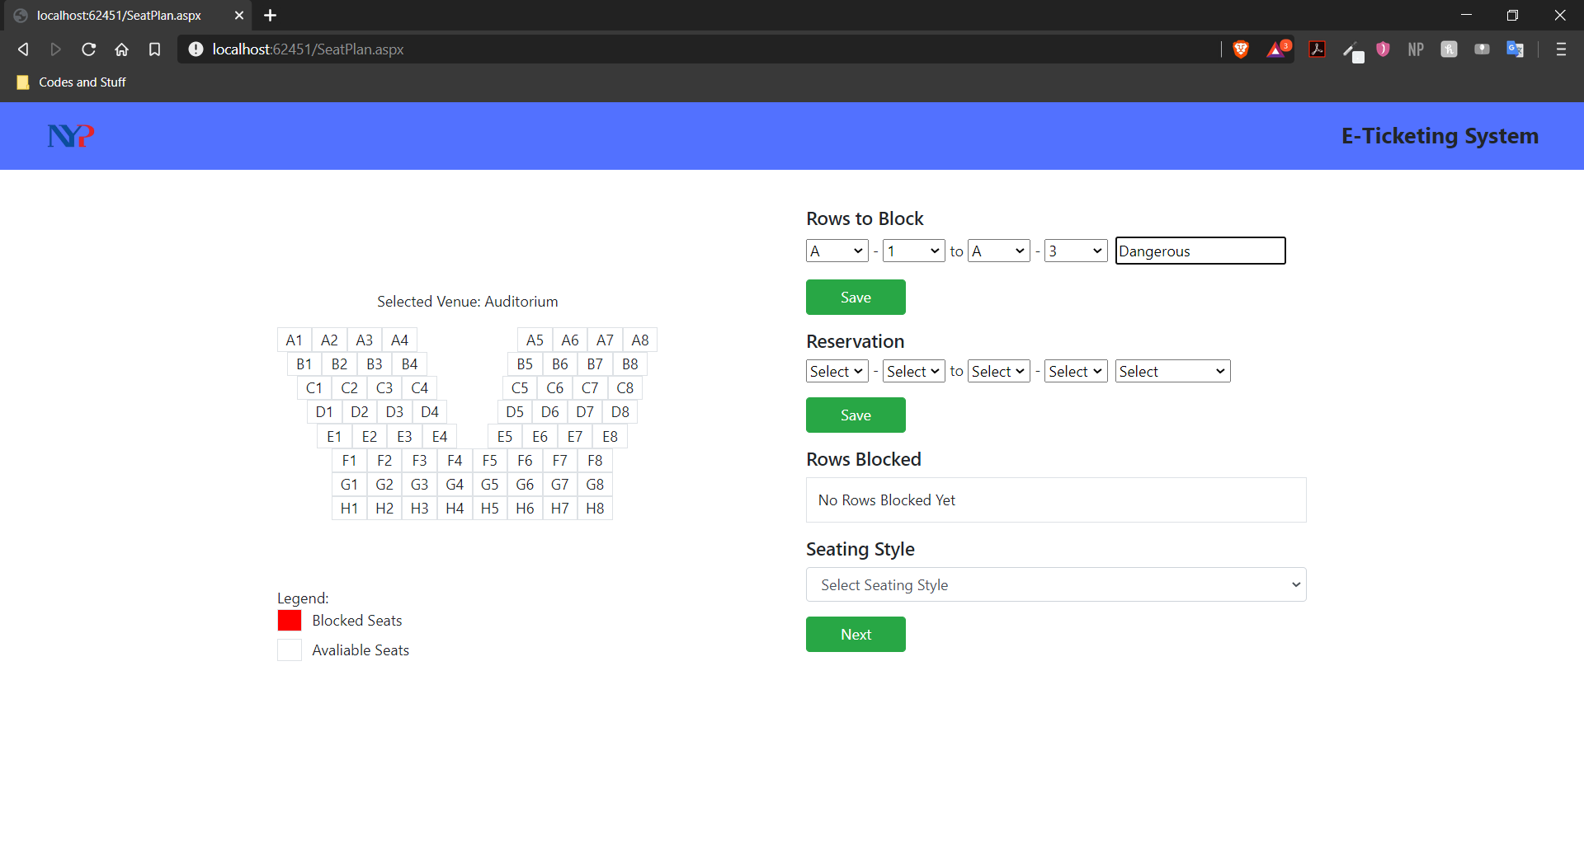

Click “Save” under the Rows to Block to save the input.

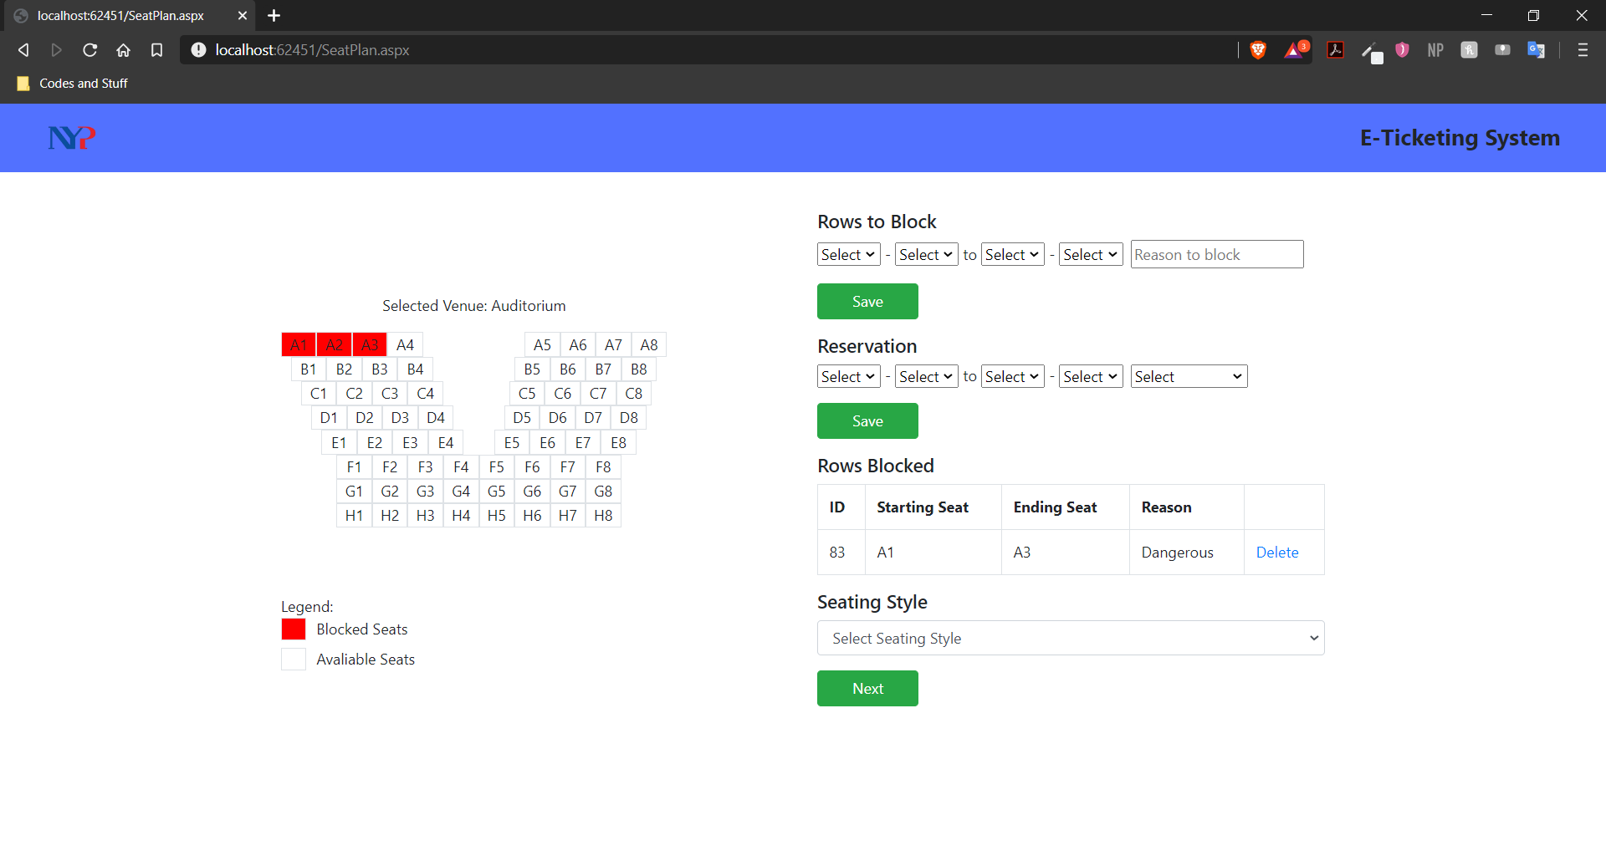

Once completed. The map on the left side will be updated to show the blocked seats and the gridview would show the record as well as the reason.

For seat **RESERVATION**, you would be looking at the Reservation column. To reserve seats, it is the same idea as blocking. You would have to select a seat alphabet and a number as the starting seat from the first 2 dropdown list under Reservations.

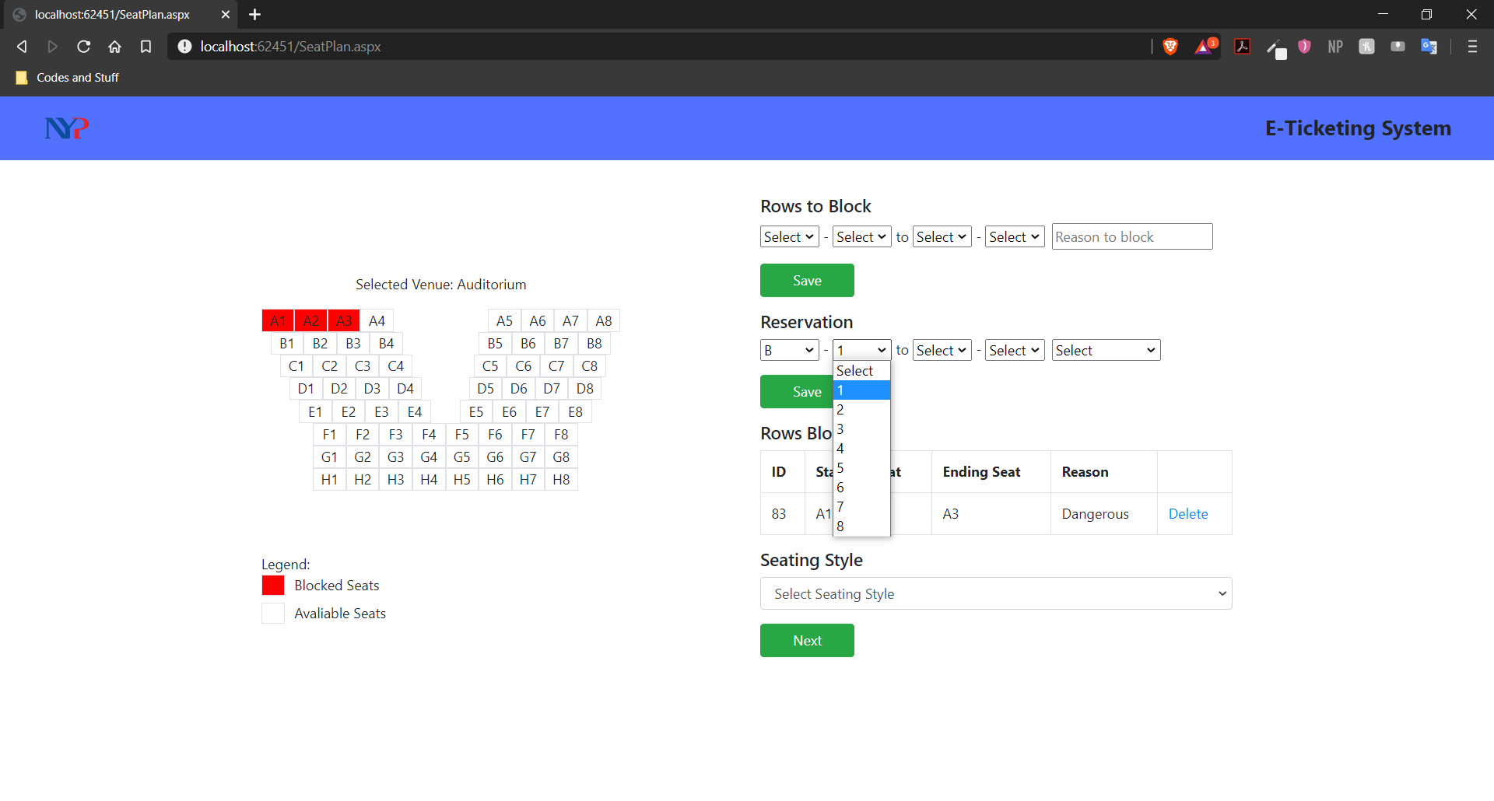

Then you would select the ending seat alphabet and number from the last 2 dropdown list under the same row.

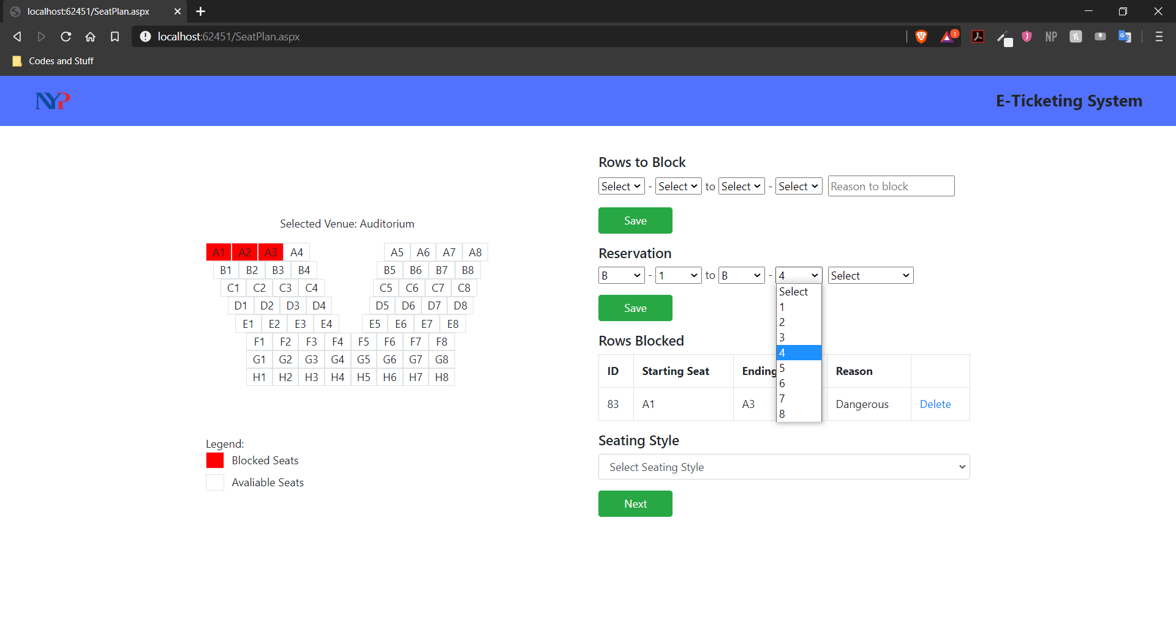

Afterwards, you would have to select from the last dropdown list as a reason for the blocking (Normal, Special Needs, Handicaps)

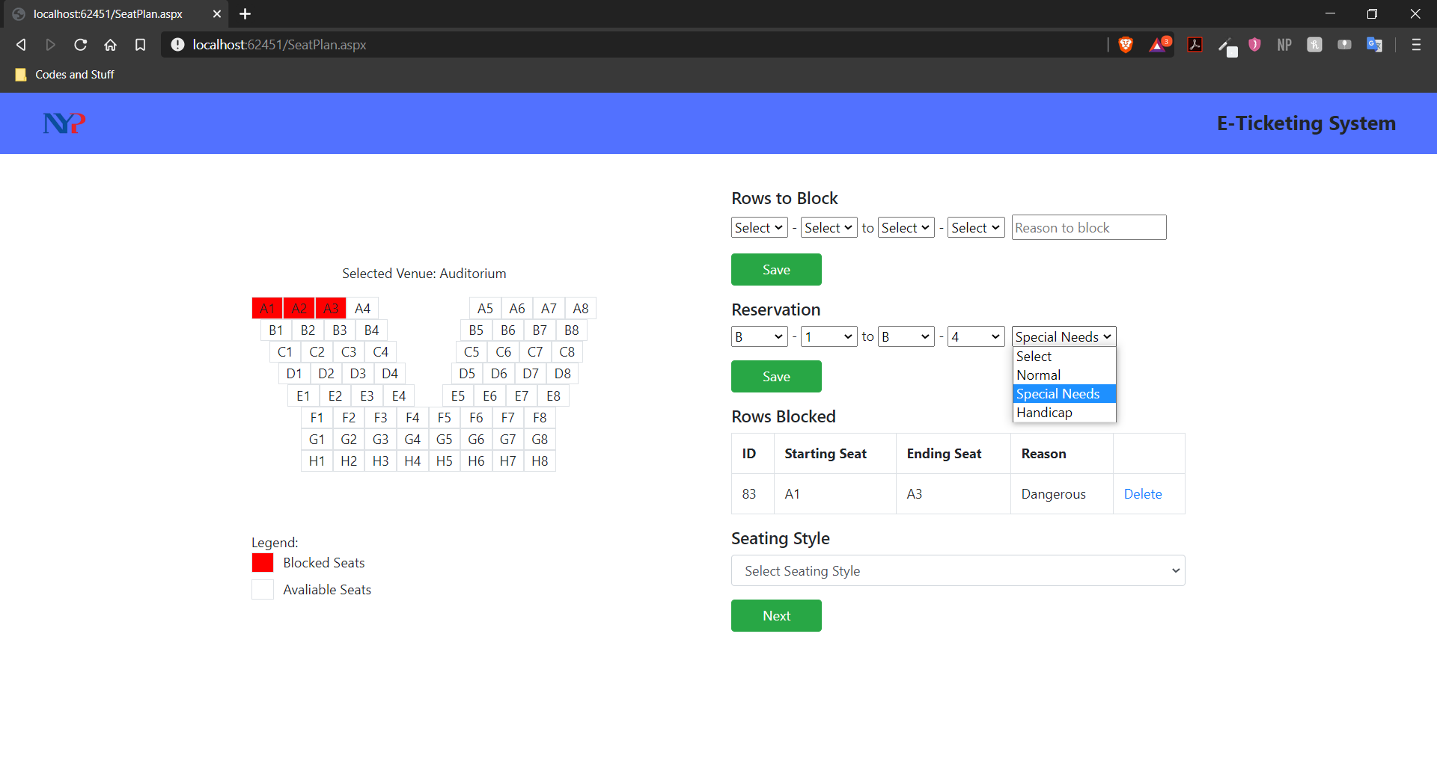

Once you have selected all the inputs from the dropdown list, proceed on clicking the “Save” button to reserve the seats. Upon confirmation, the output will look like this.

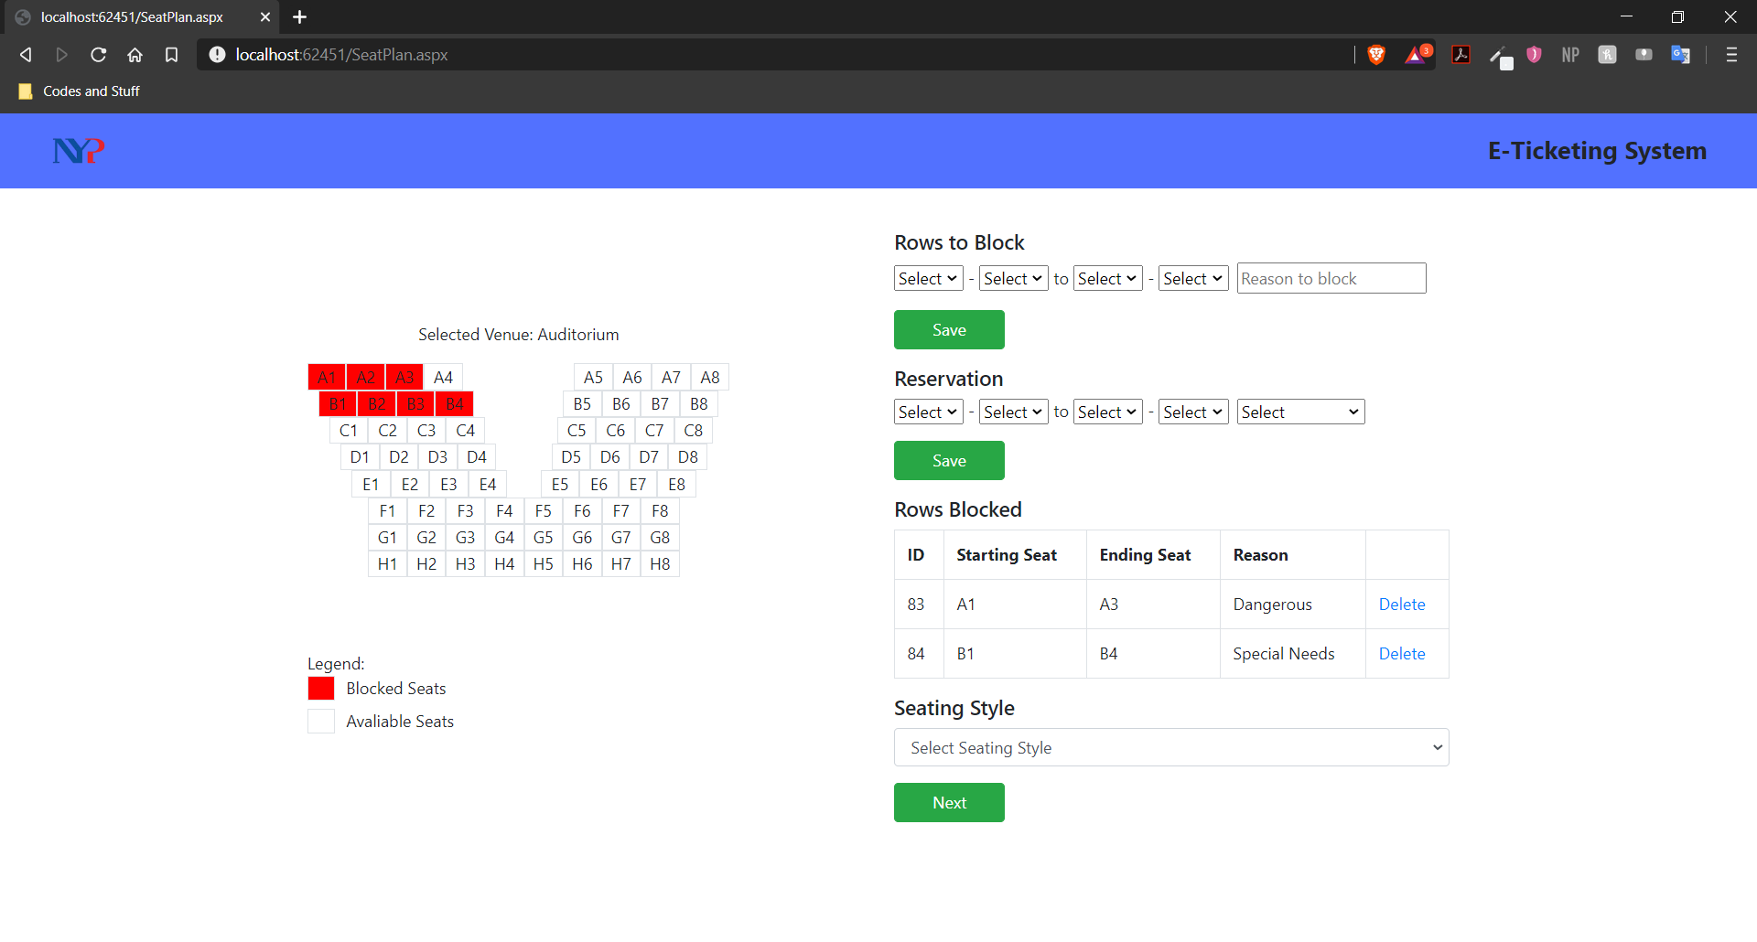

**Input Validation**

The first validation would be if seats are in the same row.

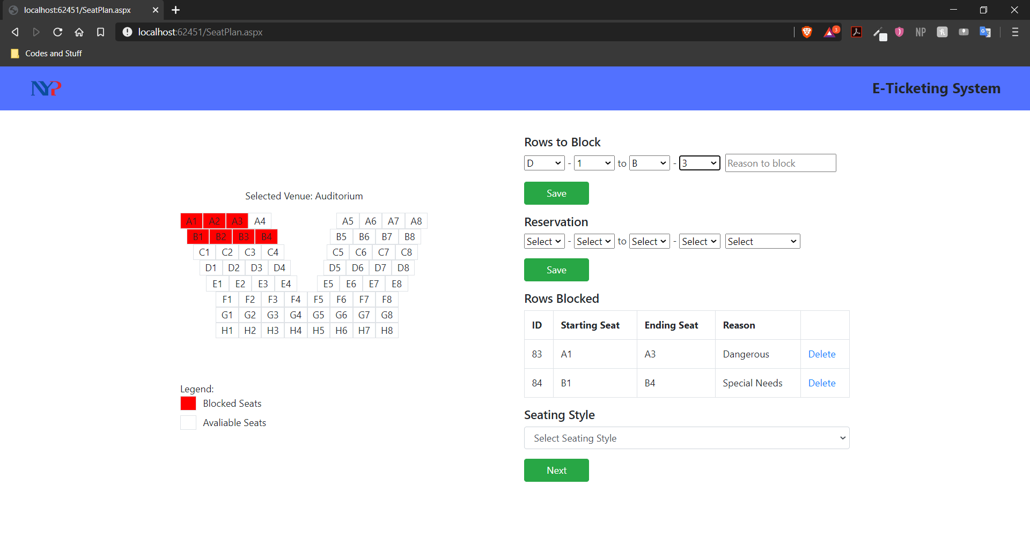

If the user would submit a request like this where the starting seat row is not the same as the ending seat row. This error would appear.

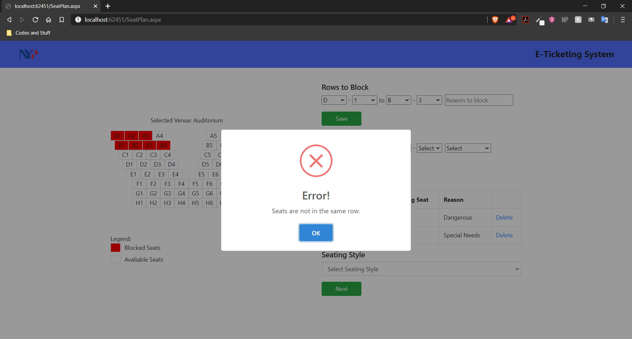

The second validation would be if the seats are in ascending order 1,2,3,4 and not 4,3,2,1.

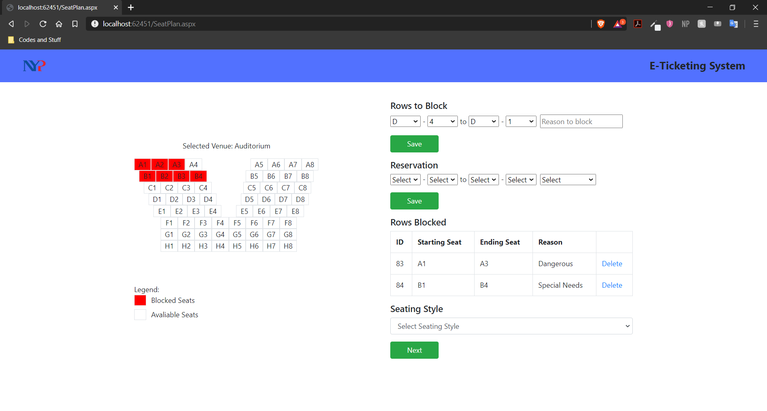

In an event the user selected the seats in descending order. The following error shows.

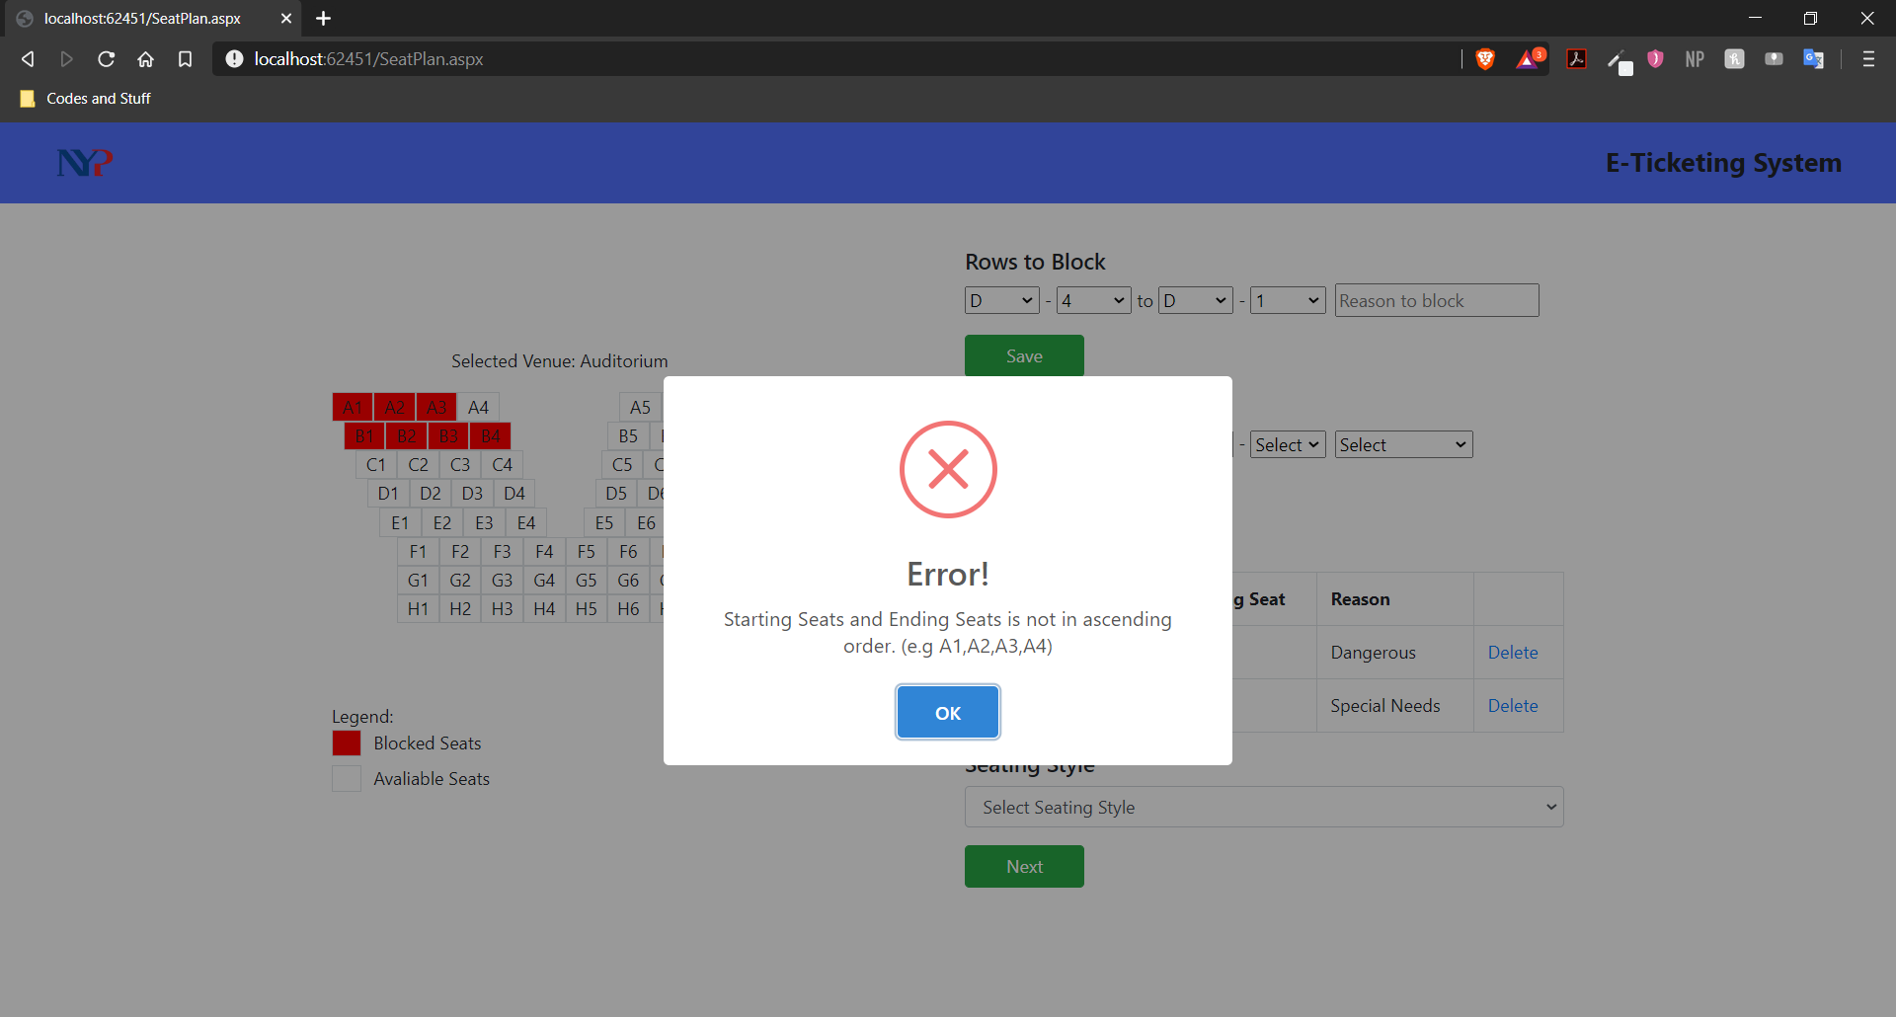

Lastly, the system will check if the input overwrites any reserved/blocked seats.

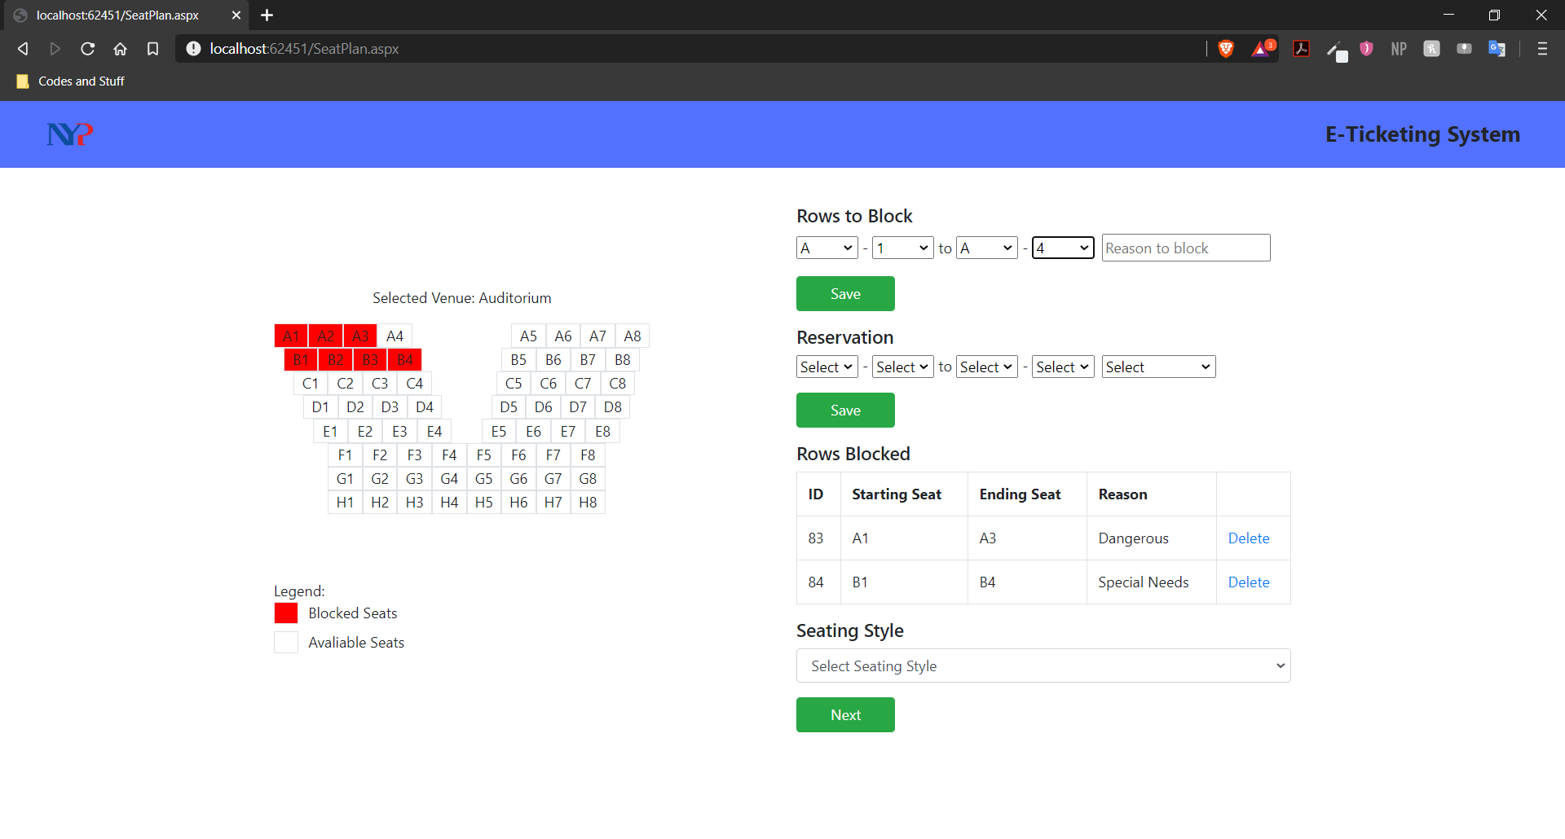

In an event this happens, the following error will show.

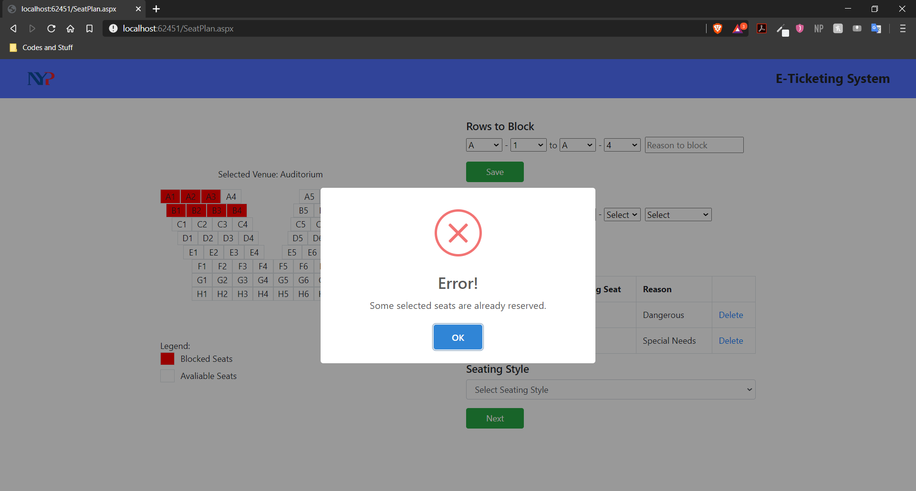

**User Guide(Guest Input)**

When launched, the user will be faced with this page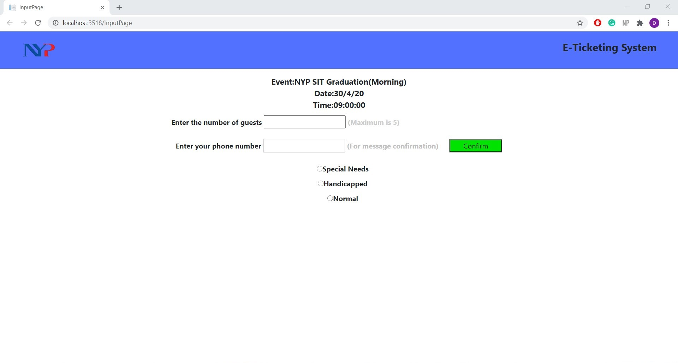

The user will then input the text boxes with the number of guests and the phone number of the guests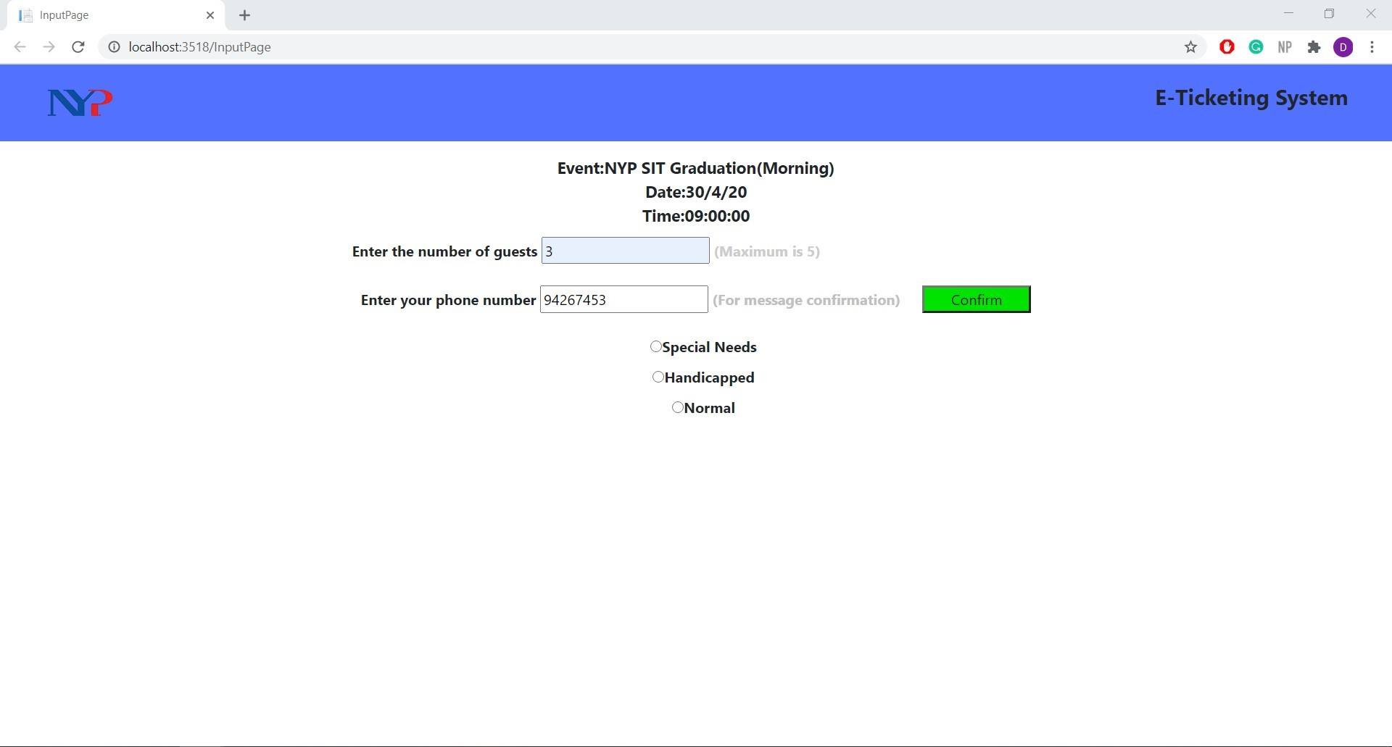

After that, the user will ask if the guest will require any special arrangements for their seating

The program will then allocate a seat based on the remaining seats left in the database and whether any special arrangement has been selected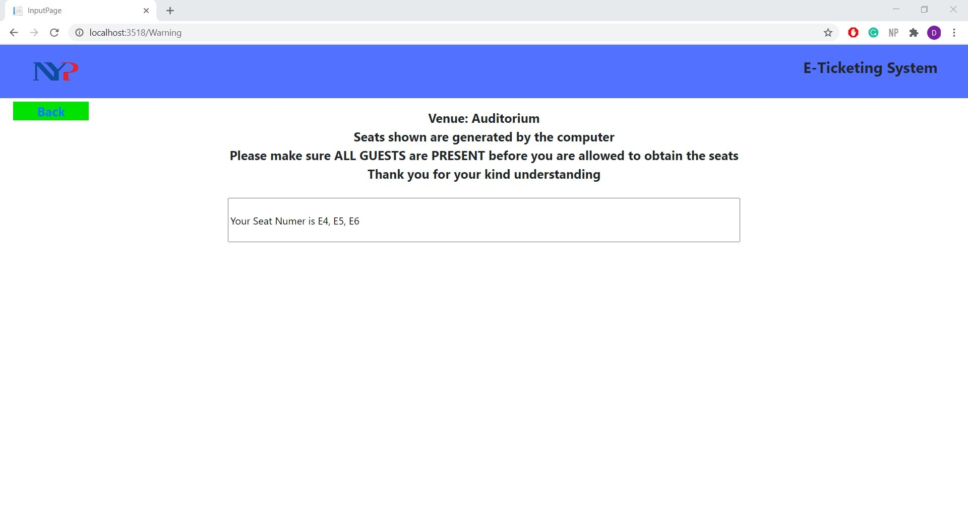

The guest will also receive an SMS to indicate their seat number, venue, time, date and number of guests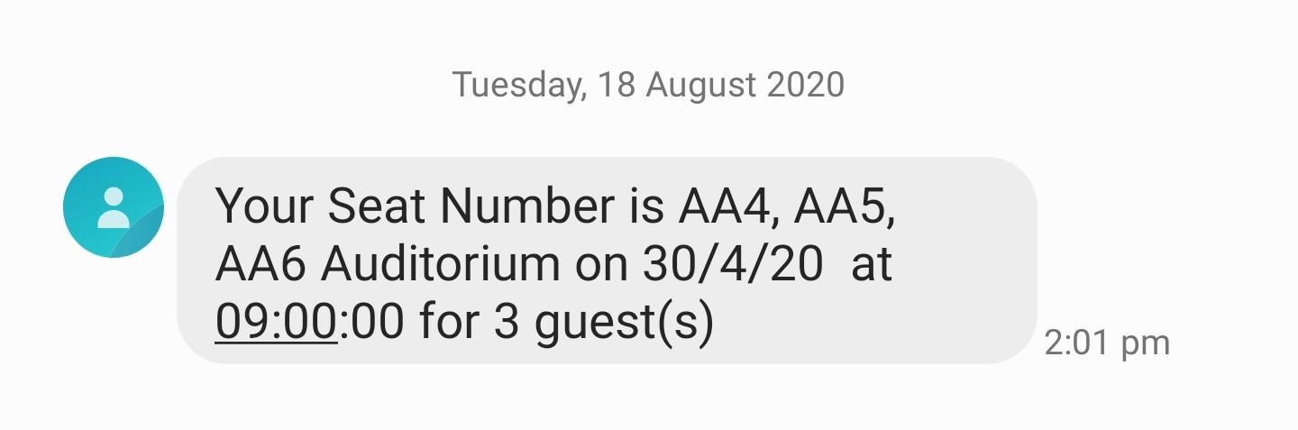

**Challenges and Reflection for Interim**

* We didn’t know much about design thinking. Hence, we had multiple drafts and changes for the mind map.
* We also had to contact, arrange and match our timing towards interviewees, so that we could interview them.
* We had to read up design thinking slides to help us understand the process better.
* We had to maintain discipline as the first 4 weeks was work from home.

**Challenges and Reflection for Final week**

* This fypj has been really helpful for me because I got to experience a new type of project with a lot of challenges to consider. I have to also learn new ways to code like Ajax and WebMethod. This is a good project to learn from.
* This Fypj has allowed me to have a deeper understanding of the design thinking process as we had to go through several revisions of our design thinking and our solution at the end too.

**Project Challenges**

* Map have to be updated to show the reserved/blocked seats
* Figuring out how ajax and webmethods works as i did not have any experience with them
* Setting up the program to be able to use the SMS service on short notice
* Not able to make the map responsive and curated to the user specifics
* Making seats color coded based on it being reserved or blocked
* Unable to have a working algorithm that allocates seats automatically
* Spent 12 weeks before the current fyp doing mobile app development had to remember how web app development as it was different

**Areas of Improvement**

* Map can be responsive and customisable for special area
* Seat reservation drop down list cancelling out seats that are already reserved
* There was not any user test done
* Different color for block and reserve seat
* Use of an algorithm to allocate seats instead of hard coding the messages and allocation

**Conclusion**

* Prototyping was difficult as there were a lot of things we have not considered while creating it, therefore there were multiple drafts of it. I also had to change them midway through development as there were some limitations too.
* Coding the prototype out definitely helped us to understand the way things work and how we should be prepared for each outcome/possible scenario.
* We also needed to think of several ways of how the database should be designed to fit the appropriate challenges we face and also think about user interface to make it more friendly for all ages